Experiment No.: 05
Experiment Name: Implementation of Secant Method.
Theory: The Secant method is an iterative numerical technique used to find roots of a nonlinear function. Unlike the Newton-Raphson method, which requires the explicit calculation of the derivative, the Secant method approximates the derivative by using two previous points on the function to form a secant line. The root is then estimated as the intersection of this secant line with the x-axis. The iterative formula is:
$$x_{i+1}=x_{i}-\frac{f\left(x_{i}\right)*(x_{i-1}- x_{i})}{f\left(x_{i-1}\right)- f(x_{i})}$$
This approach makes the Secant method a quasi-Newton method, balancing simplicity and efficiency by avoiding direct derivative computation. The method requires two initial approximations and is sensitive to their choice. Convergence is not always guaranteed.
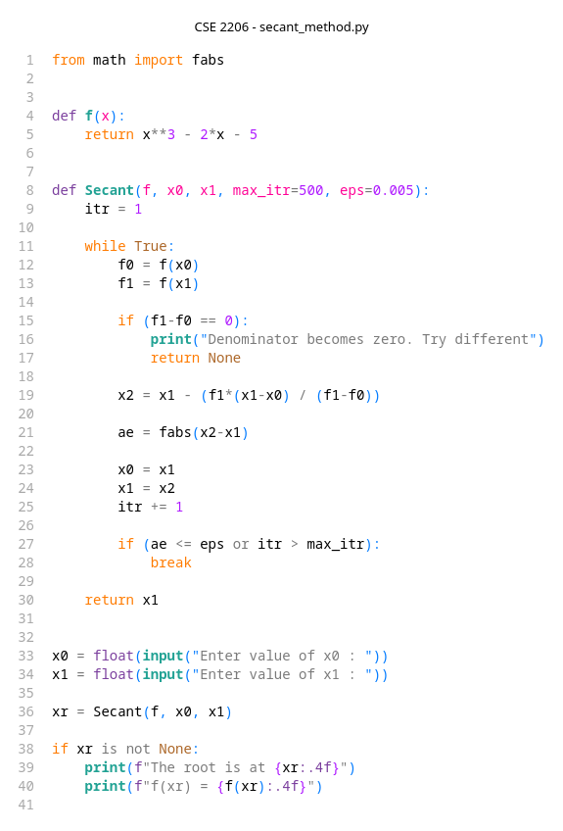
Program:



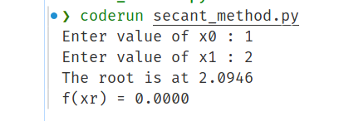
Output:

Discussion & Conclusion:
The implementation of the Secant method in this experiment demonstrated its practical utility in root-finding problems where derivatives are difficult or expensive to compute. The method successfully approximated roots through iterative updates using secant lines, showing good convergence behavior when initial guesses were chosen appropriately. However, the experiment also highlighted some limitations: convergence was not always assured, and in some cases, the method required careful tuning of initial points and stopping conditions to avoid divergence or oscillations. Compared to Newton-Raphson, the Secant method trades off some convergence speed for the advantage of not needing explicit derivatives, making it a valuable alternative in many numerical scenarios. Overall, the experiment confirmed that the Secant method is an effective and efficient root-finding algorithm, especially when derivative information is unavailable or costly to obtain.

